**Long Ride to Fairness**

**Creating a Web Application to Measure Bike Equity**

By Soren Walljasper

**Abstract**

This project attempts to design a web interface exploratory tool for users to analyze bike equity in the District of Colombia. Because of the many social perceptions and complexity of the issue we felt that it was necessary to develop an interactive tool using city and census data so users can generate concrete insight. We will visit the topics of safe bicycle routes, use-case scenario, visceral design, and interaction strategy to be able to create the most effective application possible. Through the process we will discuss the importance of bicycling as a form of transportation and the challenges with a public planning approach.

**Intro**

It’s no secret that planet earth is getting warmer. June 2017 has gone on record as the highest CO2 levels in the atmosphere ever recorded at over 409ppm (NOAA, 2017). At the same time, we are also experiencing the highest urban population the world has ever seen. In the most recent studies by the World Bank, 81.7% of people in the United Stated live in dense, ever crowding urban areas (World Bank, 2017). City planners and government officials are desperately looking for clean and reliable ways to get people from point A to point B.

One of the best ways to do this is via Bicycle. Cycling is a great mode of transit for several reasons. The EPA deems biking as a way to “protect (and enjoy) the environment” (EPA, 2015). 27% of annual carbon emissions come from transportation (EPA, 2016). Not only does biking help mitigate climate change, but it’s also proven to have a positive effect on mental health. David Byrne writes in *The Guardian* “Cycling can be lonely, but in a good way. It gives you a moment to breathe and think, and get away from what you're working on” (Byrne, 2009). Commuting by bike can be an excellent way to work relaxation, exercise, and fresh air into a busy schedule. A long ride down a stretch of trail—or even an urban bike lane—can prove to have a certain ‘zen’ component, allowing a rider to disconnect from the swarming hoard of social media (Sneed, 2017). Cycling leads to increased cardiovascular fitness, improved joint mobility, and reduced anxiety and depression (Better Health Channel, 2017). We can easily see that biking to work is good-for-you in more ways than one.

However, not everyone in the US has access to the resources, equipment and most importantly, a safe and efficient route to travel. Especially in the quickly gentrifying urban cores of the United States, biking is often seen as a mode of transportation for the elite, who have the fitness to keep up with traffic and can afford to live in bike-able areas. In the eyes of many urban enthusiasts it’s seen as an enemy of equity. Figure 1 shows an example of a post in *New Urbanist Memes for Transit Oriented Teens*, a 24,000 member Facebook group dedicated to discussion on urban transit. Claims are made about the downfalls of biking relating to range, safety, and road space competition with busses and other transit. A stigma about the culture of biking is a limiting factor in promoting ridership especially among those who need it the most, but ultimately the equity of bike-ability is hard to measure.

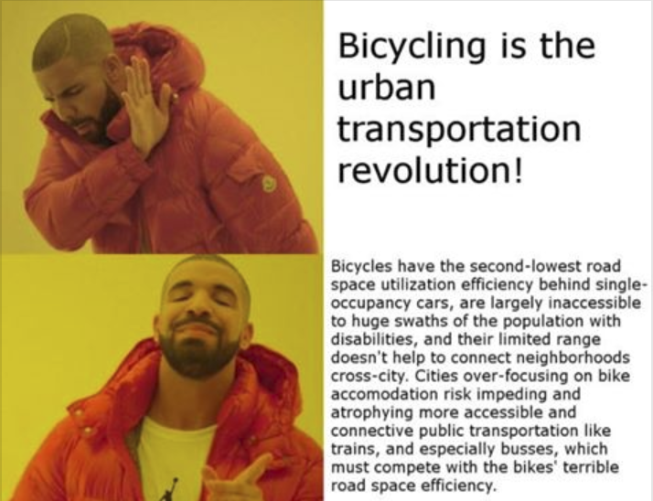

Fig 1 (Rees, 2017)

There is a need for the public, as well as policy makers and planners, to have access to imperial evidence about bike inequity, so they can make informed decisions and ultimately make biking more accessible for everyone. The purpose of this project is to create a comprehensive tool that people can use to see the spatial patterns in all types of bike routes with respect to marginalized people groups and those in need. That way planners will be able to identify gaps in coverage of bike routes from neighborhood to neighborhood so they can take action to make sure the trails and lanes are serving those who need it the most. This will allow for our streets to become less congested, and our population and planet to take a step towards better health.

Bike equity is a large topic, however so in order to develop this tool, we will need to narrow our empirical evidence down to a specific frame. The largest and most tangible factor of bike inequity in the U.S. is the disparity of safe bike routes within an urban area (Miller, 2017). In order to examine this inequity comprehensively, we need to analyze it at a large spatial scale, zooming to the individual block group to get the most nuanced look we can. Because of the time constraint and overall scope of the project, we will have to narrow our focus onto one city: Washington, DC. From 2006 – 2016 Washington has increased its bike ridership by 130%, making it the second highest in the country at 4.6% (American Fact Finder, 2016). It has also seen some of the most intense gentrification in recent years. The urban core has seen a median income increase of 10% over the last three years, while the metro area saw a rise of only 2% (US Census Bureau, 2017). DC’s combination of swelling bike ridership and an increasing wealth imbalance makes it the perfect geography for us to analyze. We intend to create an exploratory data visualization tool for policy makers and interested parties to analyze the disparity of bicycle routes in DC, and that by the time this project is done, we will have a tool incorporating census demographic data and bike route quality, for exploring the equity of bike routes in Washington, DC.

**Literature Review**

**Quality of Routes**

The first metric we need to establish is what constitutes an effective bike route from an ineffective one. According to the Journal of *Transportation Planning and Research,* “Most surveys show that the perceived traffic danger of cycling is an important deterrent to more widespread cycling” (Hull and O’Holleran, 2014). Medical costs from non-fatal bike injuries have risen to $789 million a year. The fear of an accident is a major factor in people’s perception of cycling, especially with marginalized populations who often cannot afford the cost of a crash, nor the incapacitation in the aftermath (Fernandez, 2017). We can clearly see that safe routes are the most likely to be utilized by commuters, especially those from marginalized populations. This leads us to the meaning of a “safe bike route.” There are many factors that determine the safety of a route. It’s typically a qualitative measure of feel. Many commuters are more likely to bike on a route that has a safe feel, even over a route that has less reported crashes (Hull and O’Holleran). The answer to the question “Does one *feel* safe?” on a specific bike route is heavily dependent on age, time of day and other non-normalized factors. In order to work this metric into our cartographic schema, we need to quantify this feeling in ordinal data type, ranking routes on being more or less safe.

We found that the defining factor in safety of a bike route was its separation from car traffic. *The National Institute of Health* found that with separate bicycle lanes, the probability of a crash decreased significantly (Chen, 2012). 85% of reported bike accidents are shown to have taken place between a bicycle and an automobile (Hull and O’Holleran). A study done by *Environmental Health Perspectives* shows a strong correlation for the number of cars on a road and the amount of both minor and serious injuries sustained by cyclists (Macmillan, 2014). It’s extremely clear that in order to have an effective bike route, we need to have separation from cars.

A simple solution to avoiding car traffic on a bike is keeping off the busy streets. This may be a good option in theory, but in Washington and many other cities, these low traffic roads lack connectivity to other parts of the city and often run for only several blocks at a time, rendering them ineffective as bike routes. For maximum utility and efficiency, we need to get riders on the through streets. The District of Colombia and cities across the U.S. have three main ways of doing this safely (DC, 2017). The first, and safest, is a protected bike lane. In a protected bike lane, cyclists are completely separated from the rest of the traffic by a curb or other barrier, or are off the road entirety on a separate trail (People for Bikes, 2015). These bike routes are the safest because automobiles cannot physically physically exist in the same space as the riders. Secondly, we have bike *lanes*. While these routes don’t have any structure dividing them from car traffic, the bicycles have their own designated section of road, noted by a painted stripe. These significantly help cyclists stay safe, but aren’t as effective as protected bike lanes (WABA, 2016). Lastly, we have shared bike lanes (often known as ‘sharrows’ for their arrow icon painted in the middle of the street.) The National Association of City Transportation Officials (NATCO) defines them as “road markings used to indicate a shared lane environment for bicycles and automobiles” (NATCO 2014, 45). Shared bike lanes are the cheapest to construct, but offer the least separation from the traffic and therefore the least effectiveness in promoting ridership.

Fig 2 shows the city of DC’s cartographic representation of the schema. Large dashed lines represent separated/protected routes, solid lines represent specific lanes, and small dotted lines represent sharrows. This scheme works well for a reference map, but reflects the data in a nominal way, implying that these routes are *different* rather than better or worse than one another. This makes sense coming from a map that makes sure riders know about the existence of all of the routes, however this is not what we need to accomplish with our visualization tool. Based on our research, we need to define the routes as more or less safe, with an ordinal representation, or ranking system, for routes.

../Downloads/dc_bike_map_20_0.pdf

Fig 2 (Bowring, 2012)

We will quantify the bike routes of DC in three tiers based on their effectiveness at keeping riders safe from traffic. Level one routes will be classified as anything that has a bicycle marking in the street, level two is categorized by any route that has a separate space for riders on the street delaminated by a painted line, and level three will be defined as any route separated from traffic by a physical, three-dimensional barrier. Using these criteria, we are able to show the effectiveness of bike routes in a quantitative manner to provide a platform for concrete analysis.

**Target Audience**

An important step in application design is defining your target audience. Since they are the ones who the tool will ultimately be used for, it’s important to have a clear definition of the audience early on in the design process, and keep them in mind every step of the way. “Successful exchange requires that attempts be made to find out what clients want, and then to provide services that meet those wants,” John Crompton (1980, 7) writes in *Selecting Target Markets*. In order to figure out what our visualization tool needs, we must first define who our intended user is. There are several reasons why we need this process in a cartographic visualization. Data visualization relies heavily on the interaction between users and technology (UCGIS, 2017), and factors such as age and technological skill level can heavily influence the way this interaction is perceived. Age of potential users can be a major design constraint. In a study of 50 people, raging from age 60 to 82, it was discovered that complicated symbols with small details are generally misinterpreted (Pijukkana and Sahachaisaeree, 2012). On the other hand, over simplified interfaces can deter those ready to delve in and find complex insight (Harrower and Roth, 2008). Ideally, the first major step in developing a data visualization tool is the work domain analysis—characterizing the target users and the target use case (MacEachren, 2010).

Crompton identifies two options in figuring out a target audience: either identifying the benefits sought out by a group and working to define how those groups may be characterized, or defining groups of people geographically and socioeconomically and then identifying the benefit sought by each group (Crompton, 6). Since we already know the need of our users, it works better for us to look at the first option: discovering what demographic of people are looking to seek out information on equity. Another step that can be taken is sharpening the focus of a user group. Distilling the entire user group down to a singular identity can be a way to synthesize the vast subsets of demographic data we have (Tatham, 2015). This requires development of user personas, in order to design the niches of an interface that can cater to the user’s needs. UX Planet writes to interviews, surveys, and focus groups as some of the best ways to target a user group (UX Planet, 2017). They describe that a great way to do this is gathering a “group of people potentially close to the target audience.” (UX Planet, 2017) And from there, we can work to develop a target persona.

However, this expensive process of work domain analysis is often a limiting factor in small-budget projects like this one. Processes like focus groups and user persona establishment can easily be out of scope for the project. In this case we do not have any resources at all to host a focus group. According to Rob Roth, “there are many projects where it is not possible or unnecessary to follow the UCD process” (Roth 2017, 289). Luckily, we have access to the readership data of CityLab, an online publication that publishes many short, data driven articles and graphics about urban topics, two of the most popular being equity and transportation. We can assume that for the most part, their target use-case scenario is very similar is very similar to ours. CityLab’s primary readership comes from young educated people. The median age of the user is between 25 and 34, 40% of their readers have a graduate degree or higher, and 57% earn more than 100k a year. 32% of these people are decision makers, who’s job it is to plan (Bole, 2017). Another important part of the use-case scenario is traffic information; how do people get there, and how long do they stay? Over half of CityLab’s traffic comes from social media. About 55 percent of users view the site on a desktop computer, while the rest primarily access it on a mobile phone (Chartbeat, 2017). The average amount of time users spend on each piece is around one minute.

Using this information, we can set our target use case scenario. The more specific it is, the better. For our project we will narrow it down to the following: *Avery is a 32 year old, upper middle class transportation planner who works for a private planning firm in DC. They have a graduate degree in city planning and work with computers and interactive visualizations almost every day for their job. Their task at work involves budgeting a multi-order planning project in Petworth, a rapidly gentrifying neighborhood in DC. They see the link to our tool while browsing Facebook on their laptop computer at work. They are late for a meeting, so they take only a minute to interact with the tool before gaining an empirical insight they can share at their meeting tomorrow.* This specific scenario will be able to give us direction in our design decisions, guiding the choices we make in complexity, affect and interaction strategy.

**Overall Design**

Determining the visual look and feel of the interface is one of the most important parts of the design process. Donald Norman, founder of the Norman Nielsen, group writes that there are three different types of visual design we need to consider when thinking about at interface. There is visceral design: a gut, emotional reaction to the color scheme and form of the interface, the behavioral design, which is the usability and effective information visualization, and reflective design, the memorability of the interface (Komninos, 2017). Each type of design requires a serious amount of consideration to make sure we create the most usable tool that we can.

First, we will discuss the visceral design of the interface. This is an important step in the design process, because this will cultivate the entire feel of the web application. When users arrive to the site, their first impression of the interface will determine their overall trust and mood, and will help them derive needed insights of the interface (Opach, 2009). In order to give users information they need, we need cultivate a feel of trust and authority. We can do this by using subtle, muted hues, and non-descript type (Patterson, 2013). Visceral design is one of the most important parts of the design process, and is often what makes one product stand out from another (Pernice, 2015).

One of the most trusted cartographic sources is the national park service. Millions depend their designs every year at risk of getting lost in the wild. Figure 3 shows a map of Joshua Tree National Park made by the NPS. As we can see, this map supports the notion that the NPS is a trusted organization. The shades of color in the map are muted, the icons are simple and easy to understand, and there is a nondescript typeface, establishing the message of stability. Although the basemap is a shaded relief, the entire thing is in a singular grey-scale hue, making it as simple as possible. The information about the terrain is an important context clue, but features in the basemap that are not absolutely needed, are omitted. On top of the basemap, the features added to the map are all styled in a similar fashion. The hues are all similar tones of grey and brown, which fit together cohesively. None of them stand out excessively. The typeface is a simple sans serif—clean lines with no added style. All of these design components work together to build a message of stability and trust (Desmet and Hekkert, 2007). This is the kind of cartographic design we must employ in order to get the right visceral reaction from our users.

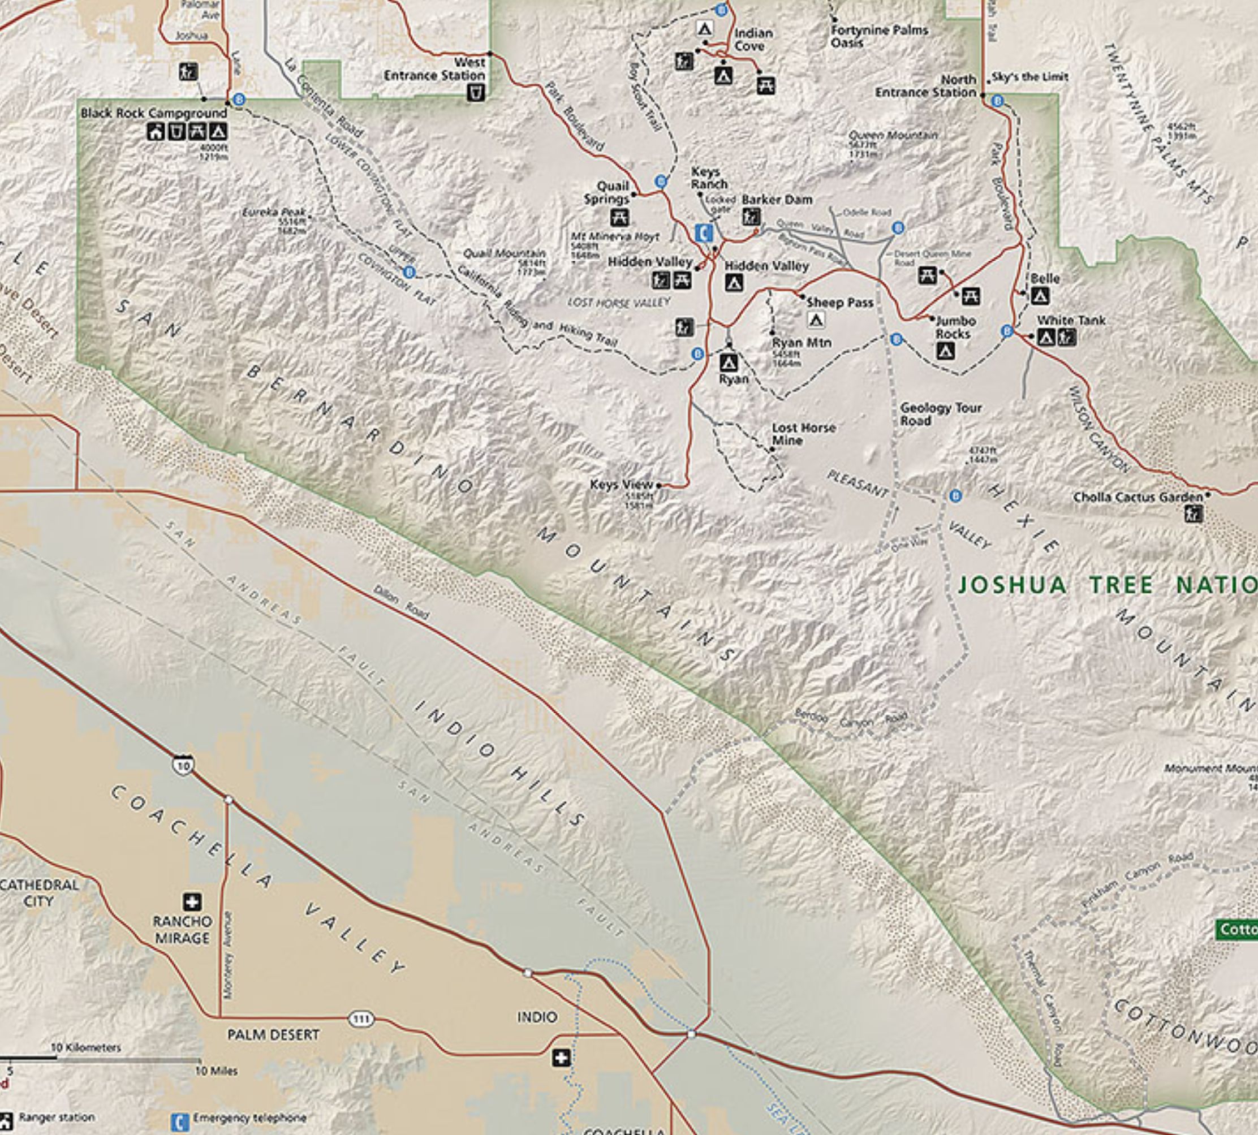

Fig 3 (NPS, 2002)

The National Parks Service maps are a great example of what we are trying to accomplish with respect to look and feel, however their use case scenario and functionality are completely different from what we are trying to accomplish. The District of Colombia Department of Energy and Environment recently came out with a web application called Energy Benchmarking DC that utilizes a similar visceral affect to the one we are targeting. Their goal is to inform the public and policy makers about energy efficiency within the district. Similarly to our project, they are trying to convey a sense of trust, cleanliness, and unbiased insight. Figure 4 shows us a screenshot of the website’s landing page.

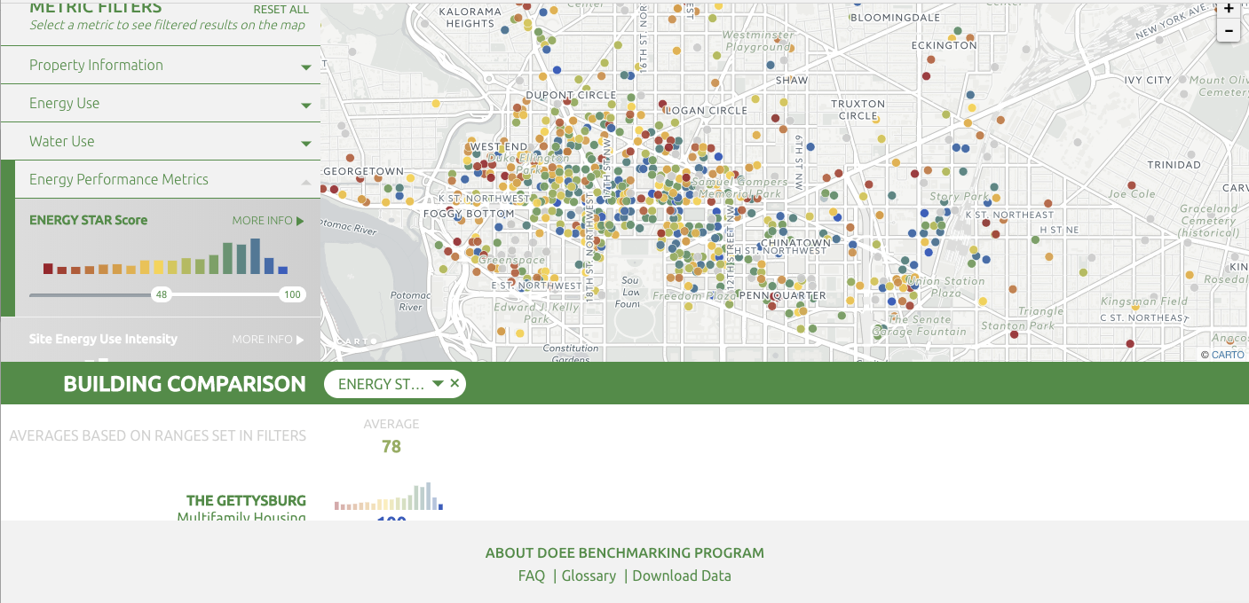

Figure 4 (District of Columbia Department of Energy and Environment, 2016)

Although a completely different type of map, we can see that a lot of the same visceral elements are similar to the National Park Service design. Excluding the data points on the map, the broad interface uses only one color-hue, and is mainly designed in greyscale. We can see that the overall contrast is fairly low, leaving the user with an initial reaction of calmness. They also use large, blocked elements that provide an aurora of security and neutrality. We notice a very similar typeface to the NPS map: a simple, noncombatant sans serif that gives us a sense of trust. All of these style choices work together to set the user’s mood in a place where they are able to retrieve insight. By looking at these two maps side by side we can synthesize the elements that make these maps work so well and try to incorporate them into our own design. Like both of them, we need our interface to get users in the right mindset so they can interpret the information that they need (Desmet and Hekkert, 2007).

We need to think about how this visceral style can be employed in our own map. In order to inform users about equity, we need to have a lot of visual complexity; many polygon and line layers all over the map. It’s often hard to incorporate a minimalistic style like the NPS while supporting the visual ramification of our intricacy (You, 2007). Figure 5 shows the default look of our demographic data when we overlay it onto our basemap. As we can see, there is a lot of information that's not relevant to the story that we want to tell. Also, there’s is a lot of unnecessary distraction that agitates the user, like high contrast between the type and the background, and far more labels than need to be on the screen.

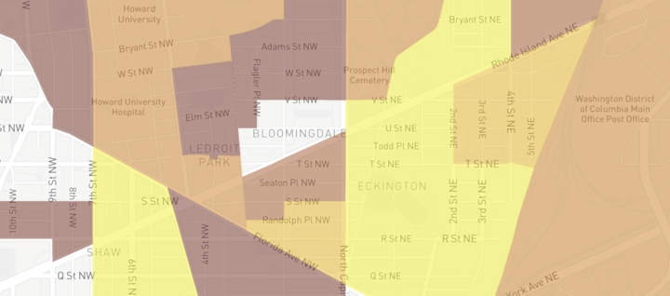

Fig 5 (Walljasper, 2017)

Figure 6 shows a national geographic magazine map, also containing polygon and line data, that still manages to create a visceral sense of calmness and trust. Notice how the single-hue muted color scheme is adapted to the polygon data, and the background includes no more relevant information that it absolutely needs to. The user can focus on the message of the data and isn’t distracted by a crowded base map. Similarly, only the features that need to be called out have labels, resulting in a simple, effective look. Reading this map calms one down, so they are able to understand the message of the map in an instant.

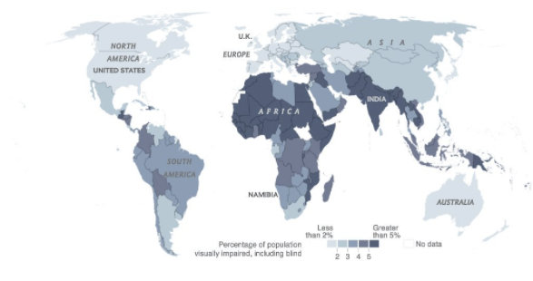

Fig 6 (National Geographic, 2017)

It’s important for our web application to have a calming interface that inspires trust. Since our target demographic and use case will only spend around a minute using our tool, it’s important that they don’t spend that limited time being distracted by unnecessary data or agitating color and form (You, 2007). In order to accomplish this, we will simplify our map as much as possible. This means that we will only include very minimal context data in our basemap, since anything more than that will distract our users from getting the information they need. Secondly, we will need to have an esthetically simple interface that suggests trustworthiness, similar to the DC Energy site. Thirdly, we will make use of low contrast block elements that give our users a sense of security and creditability. Our type will be simple and blend into the style of the interface well. If we can accomplish all of these goals, it will mean a more effective and efficient user experience (Opach, 2009).

**Interaction Strategy**

The next component we will discuss is the interaction strategy, or behavioral design of the interface. This is another very important aspect of the design. Ideally, the interaction strategy will work together with the visceral design to create the most productive user-experience possible. Norman defines behavioral design as the “pleasure and effectiveness of use” (Komninos, 2017). This is often referred to in the professional world as “Usability,” involving questions like “what types of interactions will we support?” “How will users know where they are on the interface?” or “What is the first thing we want users to do when they open the application?” These, and many more of the questions we ask, all relate back to our target use-case scenario; how effective our interface is to the people we design it for. This can be boiled down to usability: the simplicity with which one can complete their desired tasks, and utility: the ability to meet the user’s overall goals; essentially what can be achieved. (Roth, 2013) These two objectives often work against each other, creating a paradigm.

A large part of designing an effective interaction strategy is balancing this paradigm (Norman, 2011). An example of high utility and low usability is ArcGIS, a geographic information system application. Users generally come to this program knowing exactly what they want, and are able to complete highly complicated and specific tasks. This power comes with a tradeoff, however. It often takes years to become adept, and users often have to look up how to do something that they’ve done several times before. In short, one can accomplish a lot with ArcGIS, but it’s hard work. An example on the other end of the usability-utility paradigm is Pandora, a music-listening and exploration application. Pandora has a high level of usability and a low level of utility. Users are only presented with several buttons, all laid out in front of them, which needs no explanation. However, Pandora doesn’t even allow you to select a specific song; your only main options are to play, pause and skip. Figure 7 shows the extreme differences in the visual look of these two interfaces. We can clearly see that one is very complex and confusing and another is elegant and simple. This doesn’t mean, however, that one of these interfaces is better or worse than the other. They are both, in fact, very successful. Each interface is designed for a completely different use case scenario. ArcGIS meets the needs of a GIS professional, whereas Pandora meets the needs of a commuter who doesn’t have a free hand to select a song choice. Knowing where a product stands on this usability-utility paradigm is one of the most important reasons that so much time is put into developing a use case scenario: we have to know who we’re designing for (Roth, 2013).

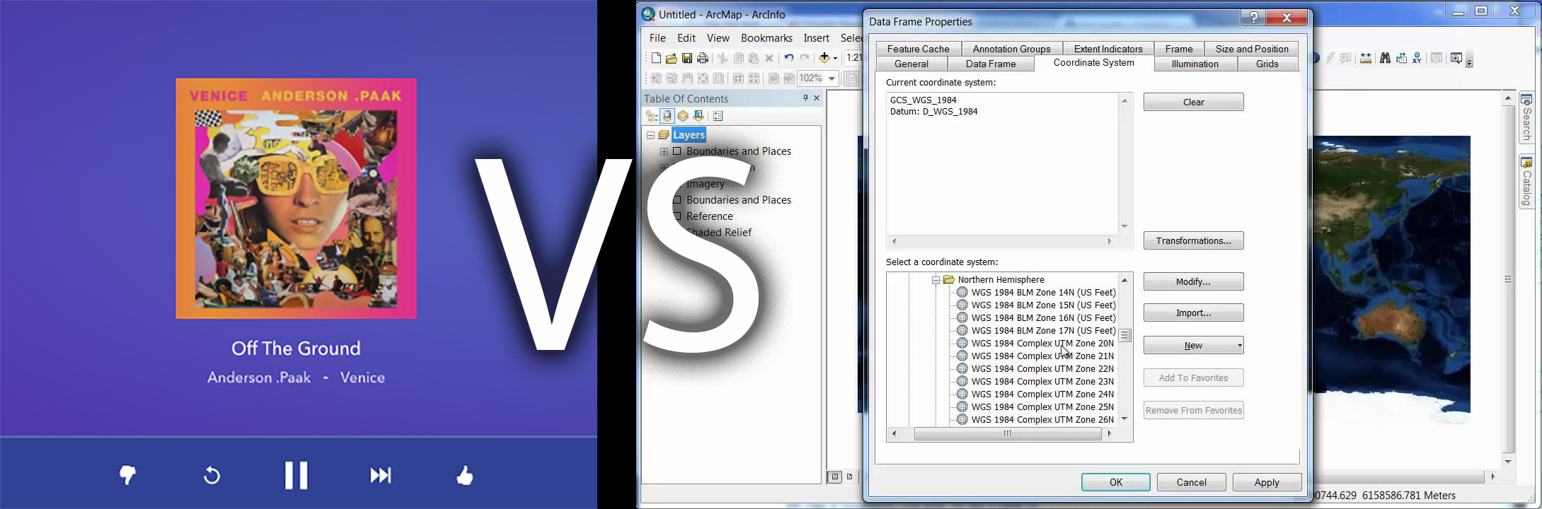

Fig 7 Pandora versus ArcGIS

In this istance, we are designing for a use-case in the middle of these two examples. Since we want our user to gain informational insight, we need to have a certain amount of intricacy, but since our use case scenario only allows for a minute with the product, we must also make it efficient, and easy to use. There are several ways we can think about designing with a balanced usability-utility tradeoff. With every decision, we must keep the user in mind (Norman, 2011). Figure 8 shows a screenshot from the national gallery of art. We can see that near the top of the page, there is a bar showing the filters that the user previously applied. It’s very important for the user to be able to see what is going on in the application at any given moment (Nielsen, 1994). Similarly, they are able to recognize that they have these filters applied rather than having to remember what they filtered in the past, another important way to maximize usability (McKay 2013, 22-45) Thirdly, the filters bar offers an option to clear any action that has been done, allowing the user freedom and control. This means that they are able to undo any mistake they have made with a single click of a button, not having to restart their search process from the beginning. This is important because, “users often chose system functions by mistake and will need a clearly marked ‘emergency exit’” (Nielsen, 1995). Allowing for users to make mistakes and undo them easily is crucial, especially in a complex interface. These design tropes will help create the most effective interface for users to get the insight they need.



Fig 8 (National Gallery of Art, 2017)

Another way for us to maximize our usability and utility is by creating an effective and easy to learn interface. We will strive for transparent design, or “an interface that requires little-to-no learning to use” (Roth, 2017) There are several ways to make sure this is being done. The first is trying to design the interface to resemble things in the real world as much as possible (Nielsen, 1994). A couple examples of this include the drag-and-drop method of file sharing and the top-left-corner back-button employed in many browsers. The drag-and-drop method is when an interface, like dropbox, allows a user to click and drag a file from their computer over a designated section of the screen and let go of the mouse, uploading the file on the spot rather than having to navigate through their browser. This interaction may sound ultra-high-tech, but all it’s doing is mimicking a real-world file cabinet. We pick up a piece of paper, carry it over to the drawer, and drop it in (depending on our level of organizational prowess). The top-left back-button is based simply off a print book. To go back to a previous chapter, we turn our page back to the left. These successful user interaction examples are only mimicking the real world.

Learnability isn’t the only way we can make sure that our interface is transparent. Memorability is another way of making the most effective user-experience possible. One way of doing this is employing an interaction strategy that users are familiar with (Maguire, 1999). An example is the “hamburger icon” shown in fig 9. This icon is universally used for activating a dropdown navigation menu. Almost everyone who is familiar with using a smartphone will have seen this in the past and know exactly what it means. If we used a magnifying glass icon to activate a menu, users would assume that they would be opening a search bar. There is a universal language that users have grown accustom to. Just like one wouldn’t say “stop,” when they mean “hello,” we cannot use a hamburger icon to mean “search.” This doesn’t only apply to icons, as in the example above. Unexpected layout of a site also confuses among users (Sherwin 2013). Generally speaking, enabling actions, such as navigation and window deployment, are located on menu bars at the top of pages, while direct actions, like clicks that generate insight or achieve tasks, are located within those. Changing up the interface layout and protocol makes our interface less transparent, and ultimately makes it harder for users to accomplish what they need (Harrower, 2008).

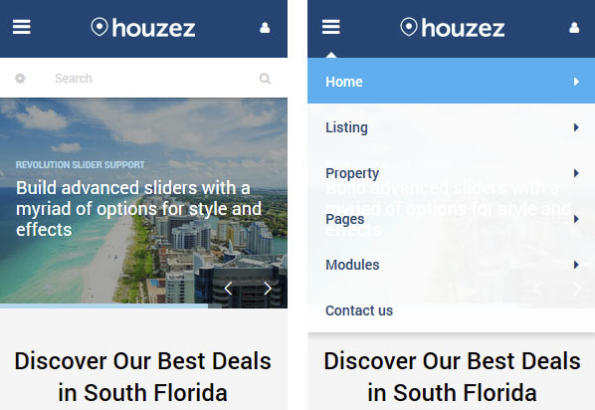

Fig 9 (Google Images, 2017)

Figure 10 shows an interactive map tool that examines bicycle crashes in New York City. It’s not exactly like the tool that we are trying to create, but draws several similarities in use-case. It could also be viewed by planners and concerned citizens, in a short engagement window. We can see that the interface is very complex, falling on the utility side of the usability-utility paradigm (Roth, 2017). Users are able to filter by type, date range, and boundary. They can find everything they need to configure the map on a panel, located on the right-hand side, which is joined with a bottom panel, showing specific values. The panels frame the map, creating a clear separation but limiting screen-space that the user can gain insight from the map. The tool also allows users to hover over a specific data point on the map, and retrieve minute details. There are many ways that a user can find the information that they want to, however it may take a user several minutes to find out exactly what they need.

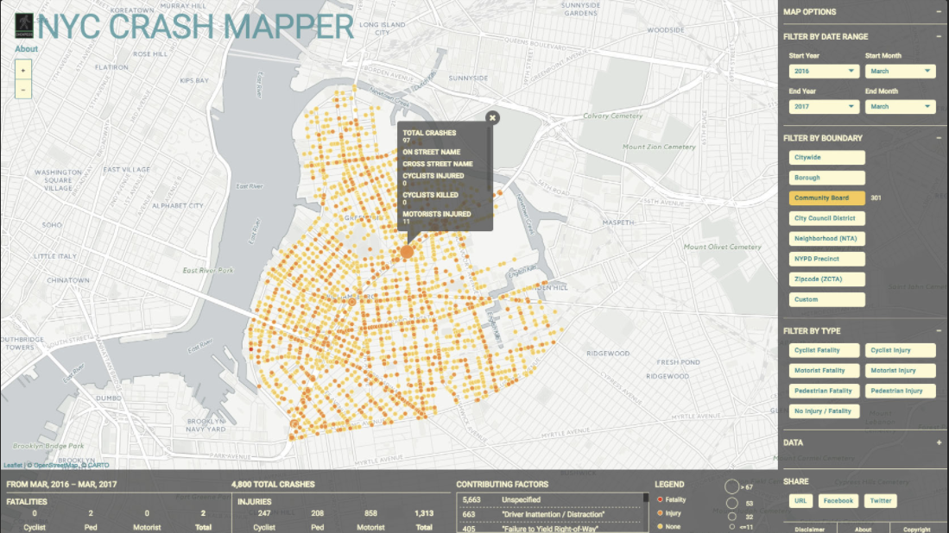

Fig 10 (Hendrick, 2017)

We will examine each individual filtering tool to see how it creates an effective user-experience. The filter-by-boundary button list works well. It shows all of the options available, giving the user a clear affordance of their available options. It’s efficient in its operation; users don’t have to access a dialogue box to complete the desired task. A tradeoff for this accessibility is a large use of space. The boundary filter takes up almost half of the right control panel. Next we will look at the time filter, which requires users to select a start date and an end date, each with a dropdown selector. This method is a bit unnatural, inefficient, and confusing for users. Rather than employing the dual selectors, it would be better for users to be able to select a range on a slider bar. This would allow them to see all of the options available, limit the amount of clicks it takes to achieve their desired task, and easily recognize what the tool is for (Nielsen, 1995). Changing it would make the interface more transparent and efficient. Lastly, we have the filter-by-type tool, which works very similarly to the filter-by-boundary tool, making for a good user experience. In summation, these tools are effective, but ultimately require time and effort from the user.

For our application, we want something that is slightly more simple and easier to use than the NYC crash mapper. If we consider our use case scenario, we only have a minute to get the user what they need (Bole, 2017). We cannot waste those valuable seconds trying to figure out how to work our interface, so it’s important that we keep our exploratory tools simple. We have to design for maximum interface transparency. Secondly, our target user is someone who is familiar with many interactive visualizations in their work. This makes it important that we utilize conventions in design (MacEachren, 2008). Ideally, we will have range sliders for selecting subsets of a specific attribute in the data, so users will get a visual expression of the available options and understand where they stand in the range of data (Norman, 2011). In order to increase our usability, we may have to sacrifice some utility, only including the tools that we need. It’s important that we recognize where we stand in the usability-utility tradeoff.

**Implementation**

Once we had a use-case, methodology and a design vision for the product, we could begin the implementation and development. This involved a whole other set of decisions that influenced how our final tool behaves and interacts. Firstly, we had to decide about the data we would use to fuel the application. The most important layers we needed were bike routes, which we found in ESRI-shapefile format easily from the District of Colombia. Next, we needed to find data that would provide context for the area, showing demographics and transportation information. Ultimately the most widespread, trusted, and easily accessed source for data of that type is the government, so we turned to the US Census Bureau to get the most quality we could within our scope. Since users need to pan and zoom our map to explore, we needed data at a spatial-scale large enough so that it would still be relevant when zoomed to the closest extent. This meant we had to look for data in block groups—the smallest area enumeration unit available for demographic data. We decided to use several metrics to measure equity, since there are many factors, finding CSV data tables for each block group in DC minority population, method of commute, length of commutes, poverty, income and area. We then used Microsoft Excel to consolidate the data into a single CSV containing identification (for GIS purposes), percent minority, percent bike commuters, percent car commuters, percent of commutes over 45 minutes, percent living below poverty level, median household income, and density, for each block group. The next step was finding geographic data for a cartographic representation and spatial analysis. We used TIGER/Line to download block group shapefile data for the District of Colombia, and ArcGIS to join the data together. Once we had all of the shapefiles with necessary attributes, we uploaded them to map-shaper, a web file-conversion application developed by the *New York Times* graphics editors. Using this, we were able to convert them to a geojson format—a text format containing geometry and properties in a keyed data object.

Once we had the data in the correct format, we began the development process. In order to do this, we first had to choose a web-mapping library. The best choice for our target use case is Mapbox GL, since it best utilizes vector tiles to integrate a basemap with our target shapefiles, cultivating a clean, effective cartographic design. First, we used an Ajax callback function to bring our geojson into the web-mapping sphere, where we could start manipulating it and creating filters and visual expression. Figure 11 shows what our map looked like when we first brought in our raw data. As we can see, it’s almost unrecognizable. We were able to analyze what the data had to offer, and decided the two most useful tools that users could generate insight from was a choropleth—a form of data visualization where different enumeration units are colored based on their value for a certain field—or by filters, the method of taking out irrelevant data so users can generate the exact insight they are looking for. Using these two methods, we could allow users to utilize the data in the most insightful way.

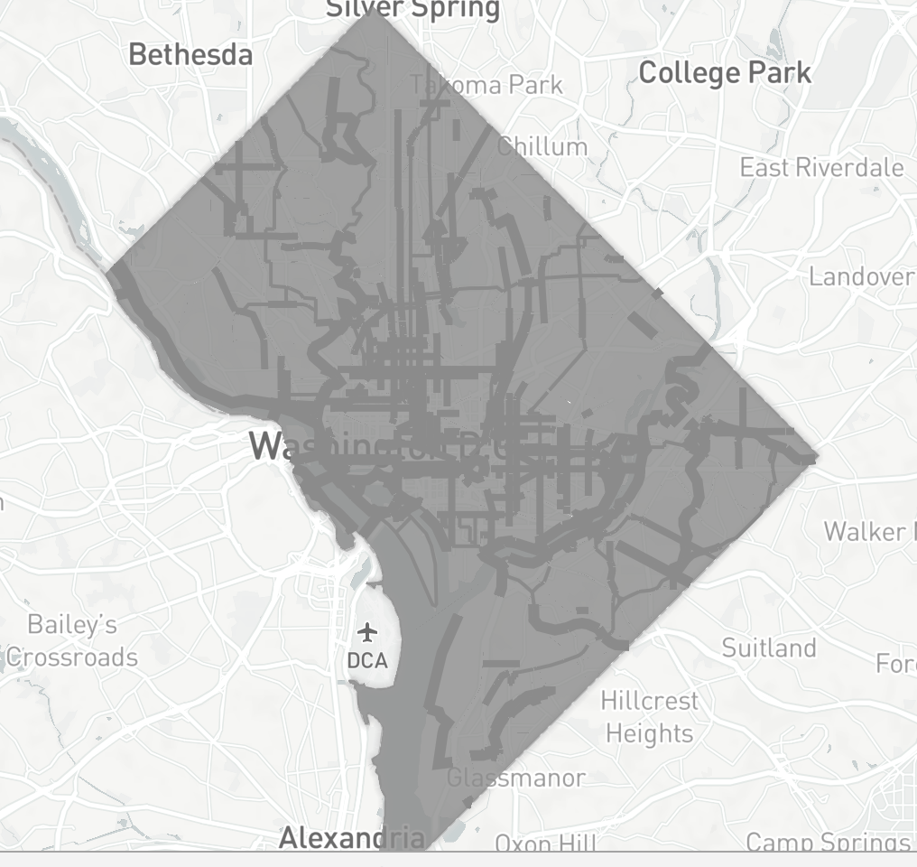

Fig 11

Our next step was using JavaScript to make this possible. Rather than thinking about how to render a choropleth first, and then figuring out how to make that visualization filter, or vise versa, we devised a schema that would do both simultaneously. That way the workflow could be as simple as possible, allowing for a faster load time. What we created was a function that took in three variables. The first is a field the user wanted to filter by, the second is a field the user wanted to visually express with a choropleth, and the third was a filter threshold (a value that each block group was measured against, and eliminated from the map if it did not meet). The function would then select the appropriate data from the json, separate it into classes on the fly, and color it based on those classes. We tested and debugged this by feeding it values manually in the code. Once we had this working, we created an interface for users to be able to select which fields and values they wanted to express with a dropdown menu and a slider bar. After that, we implemented a simplified version of this logic to allow users to show bike routes on the map filtered by safety. Figure 12 shows our interface, fully functional, but the development process was far from done.

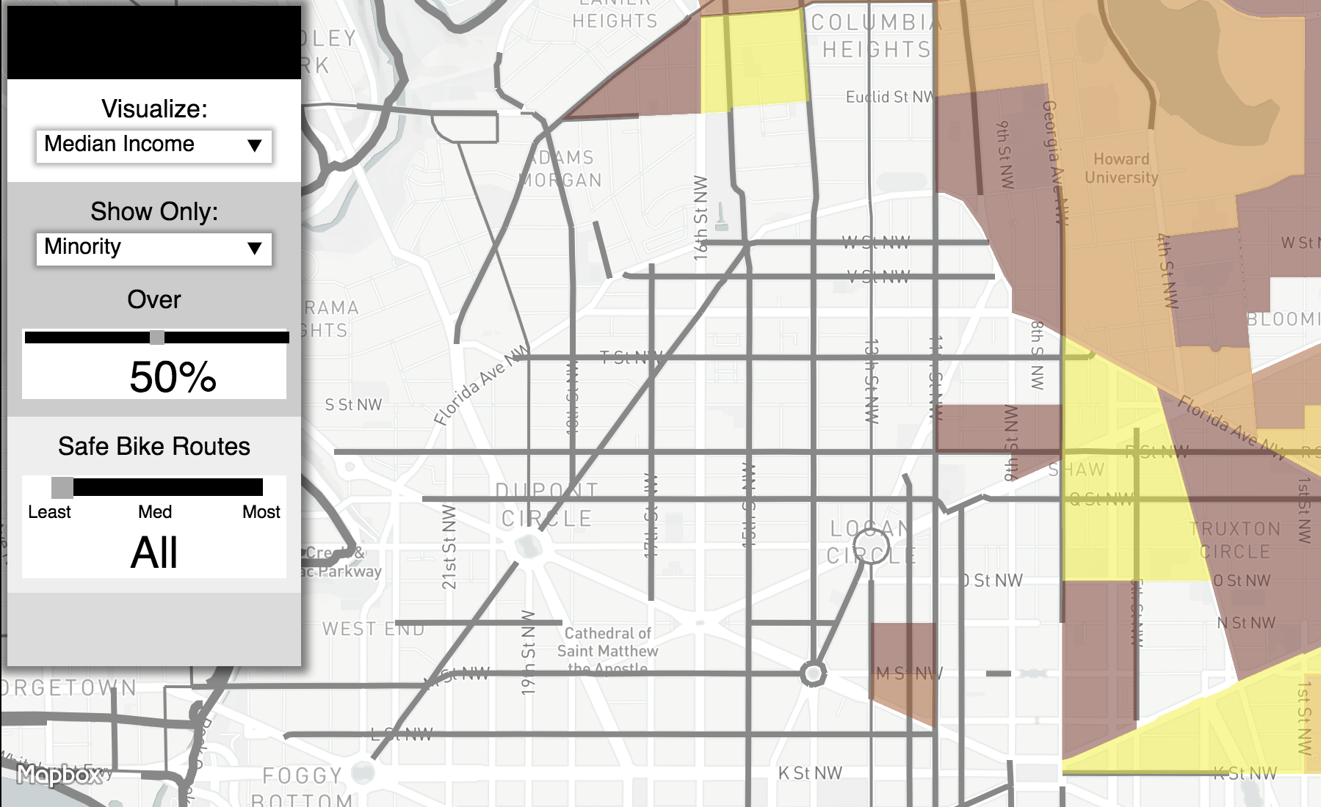

Fig 12

Our application still lacked many feedbacks, affordances, and a calming visceral design. Users would be agitated by this interface’s contrast and form, not knowing how to operate it or understand what they were seeing. Our first step to curing this was by building a dynamic legend. To do this, we created a function that was called every time a new map state rendered, drawing new boxes and class-labels every time the map loads. Next, we had to create visual affordances for users so they would know what was clickable. We implemented subtle changes in hue, shadow, and contrast when the mouse hovered over a clickable feature. This was made possible by jquery, a library that simplifies basic JavaScript methods to easier handle user interactions. We also broke up our panel into specific sections, one for filters, one for visualization, and the last for bike routes. This made our panel a little simpler, and made it easy for the user to understand what each tool was for. Once we had done this, it made our interface much more transparent. Users could now get feedback on what their actions were doing and how they could manipulate the tools to get the insight they needed.

The next step was cultivating a visceral look and feel that promoted security, trust and calmness. We were able to make several adjustments to the overall style. First, we had to simplify our map design. Our functional, yet default map in fig 12 had far too much information for a map-reader to contextualize easily. We needed to take off any labels that weren’t necessary, tone the non-biking roads down in the visual hierarchy, and focus the map on what the user actually needs to see. We were able to do this using *Mapbox Studio*, a web application that allows one to create their own custom basemap. We eliminated any information that wasn’t absolutely essential to the story we were trying to tell; when we were done, our basemap only contained water features, parks (so users would not be fooled by large colored areas in the map that contained no actual people), a few roads, and neighborhood labels. Once we had our custom basemap, we could integrate our data into it. We actually put many of our “basemap” layers above our data in our layer stack, in order to cultivate a simpler look. That way, viewers aren’t trying to read features under our choropleth areas, and we can leave the core information at 100% opacity, making for a clearer view. The final step in map design was drawing out our bike routes, since they’re the most important feature. This was likely the most challenging obstacle, since they had to stand out on dark choropleth regions as well as a bright grey background. We ended up loading each layer in twice, once as a bright-green line, and the other time as a dark-black case, so that the routes would stand out no matter what they were positioned against.

Our map design wasn’t the only thing holding back our intended style. We then had to make some changes to the overall interface design. First, we created top panel, framing the map and orienting the viewer’s eyes in a logical flow. It also provided a good spot to present the title, so users can know exactly what this map is about. Next, we adjusted the style of the filters panel and legend. We got rid of the black and white bars, making most elements a light-grey color, with green accents to match and highlight our bike routes. Our final task was choosing a typeface. We ended up going with *Futura* because of its clean, elegant look. Once we had our typeface picked out, we could change type color to better blend it in with the interface. Figure 13 shows the final product. Our interface now had a clear, effective design.

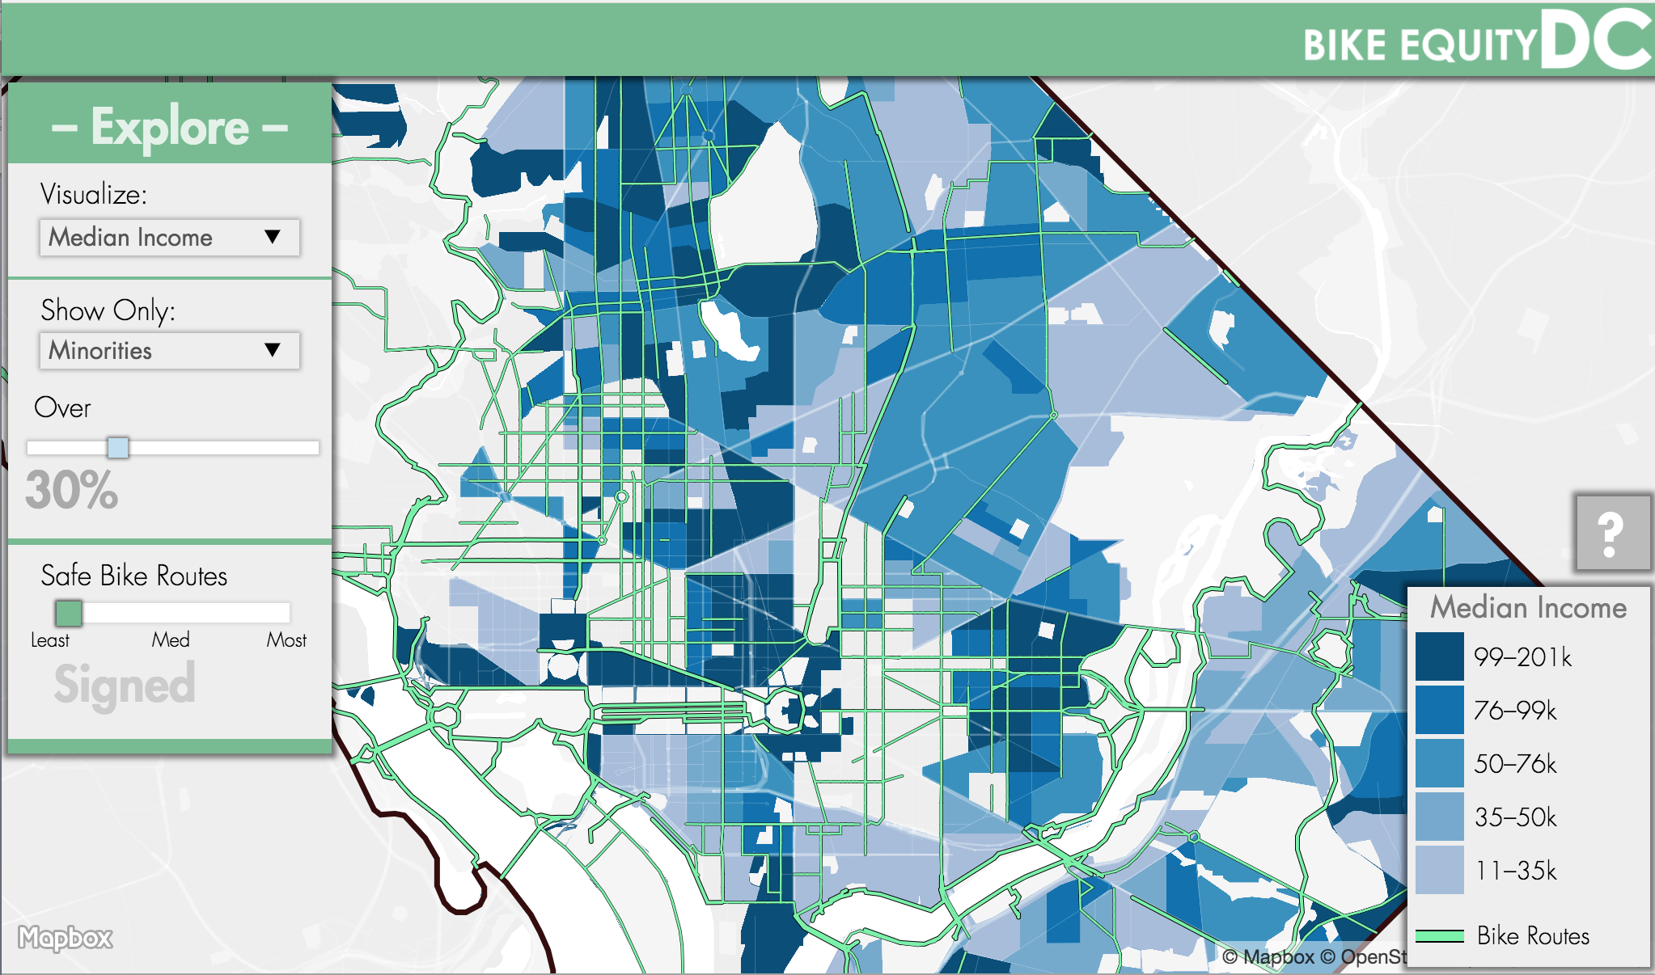

Fig 13

**Conclusion**

We were able to achieve our target goal of making an easy-to-use interface for people to explore bike equity in the District of Colombia. We found that the greatest factor in bike equity is safe bike routes. From this, we ranked routes based on safety, determining that their separation from traffic was the biggest factor, thus we were able to quantify what made them effective. Once we had our schema figured out, we analyzed how we could implement a tool, allowing users to gain insight on the equity of these routes. We categorized our target user group using data from CityLab readership, since they cover many similar topics. From this, we were able to characterize our target user as an upper-middleclass policy maker viewing on a laptop. Next, we studied several examples of how other maps, graphics, and interfaces were able to cultivate a visceral look and feel that users would trust. We determined that a single hue, low contrast interface would put our users in the right mindset to gain the insight they were looking for. Lastly, we analyzed similar applications and figured out that employing known conventions and making our interface transparent would result in the most usable tool. Taking into account all of this research, we found data and built the best tool we could in the time we had.

Ultimately, we are happy with the product that we produced; yet there are a couple of constraints that we’d like to visit. Because of time and resources we were not able to completely follow the user centered design process. If we had time and resources, we would test this product with our target user group, design a survey, and retool our product to meet the immediate needs of those using it. The product we made makes an excellent prototype, but we cannot fully measure its success unless we are able to test it with the people its designed for. It would also be ideal to be able to more clearly establish our target user group through market research. We were lucky to have access to CityLab’s data, yet a focus group and independent survey would have been helpful to see exactly who may use this web application.

Time was a large constraint in our development and design process as well. In a perfect world, we would have been able to spend more time designing for mobile. In order to accomplish an effective design in a short amount of time, we had to choose one web platform to design for primarily and then adapt for viewing on other ports. We chose to design for desktop first, since the majority of our target users viewed on a computer, according to the CityLab survey we used to define our user group. We were able to create a mobile version, but it mimicked our web interface heavily. Secondly, It would have been good to prototype our design in a series of mockups before we started implementing it with code. If time had allowed, we would have prototyped the needed functionality and layout first, and then designed a series of pixel perfect mockups to visualize exactly what we wanted our interface to look like before we started developing. Time often plays as a major constraint in any mapping or web project, so it’s important that we can do the best with the resources that we have.

Although our process wasn’t perfect, we were able to create a capable web application. Briefly using the finished tool, we were able to find that areas with high-minority populations generally have less safe bike routes than areas with low-minority populations, and among the high-minority areas, the places that are wealthier on average tend to have more routes than the poorer ones. Figure 14 shows a screenshot of our tool filtering out areas below 53% minority and visualizing median income. Being able to generate complex insights like this is exactly what our application sets out to do. Another example of insight we were able to discover that many areas that are high poverty often have the longest commutes.

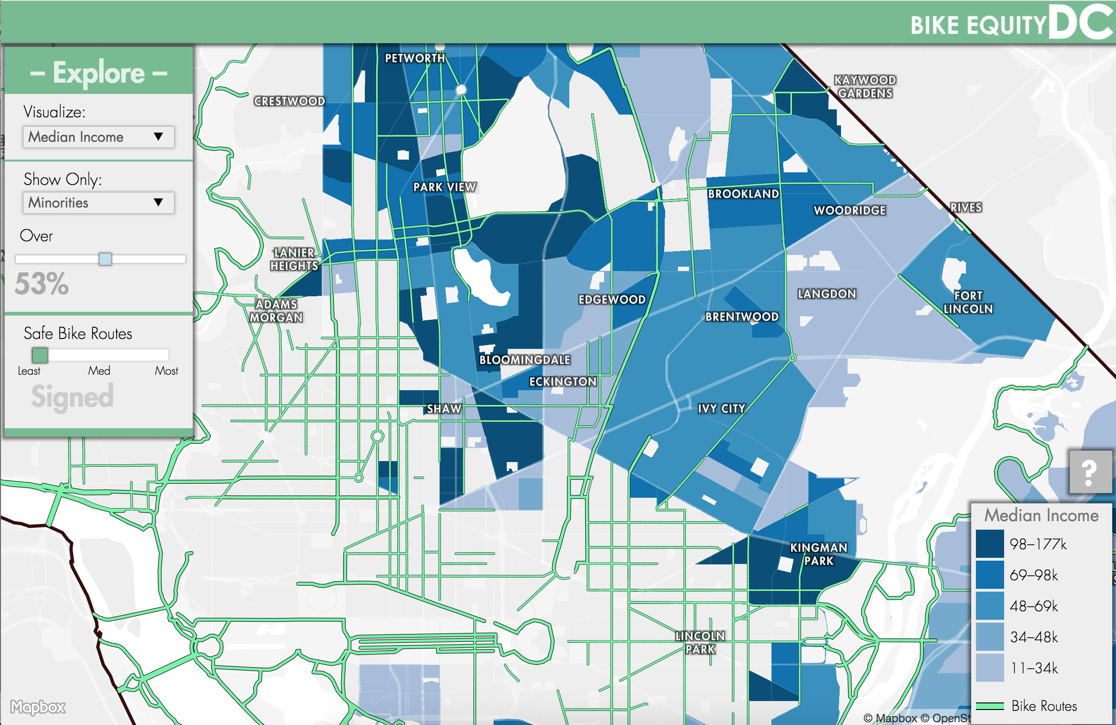

Fig 14

Increasing the amount of bike routes into areas with marginalized people could help DC become a more equitable city overall. DC isn’t exactly like many other American cities, but it can be a good example of how we can make biking more equitable for everyone, nationwide. Creating more equitable bike routes can help people with transportation, money-saving, and mental health. It’s very important that we look at a realistic and factual approach when combating these issues, and not rely solely on public perception. Being able to analyze how our cities’ transportation and equity problems are happening spatially could be a huge factor in making our cities more livable for everyone.

**Sources**

*American Community Survey.* 2016 ACR One Year Estimates. *Retrieved from American Fact Finder Download Center.* (2016) accessed October 11th 2017. factfinder.census.gov/faces/nav/jsf/pages/download\_center.xhtml web.

Bole, Rob. “CityLab Audience Survey” *CityLab* (August 2017)

Bowring, Larry. Washington, DC Bicycle Map [ca 1:2500] Washington, DC: Government of the Discrtict of Colombia, 2012. Print.

Better Health Channel. “Cycling – Health Benefits” *Victoria State Government* (2017) web.

Byrne, David. “Cycle Killer: David Byrne on the Joys of Cycling” *The Guardian* (August, 13th 2009) web.

*Chartbeat.* Publishing Sites, The Atlantic‑CityLab, (2017) chartbeat.com/publishing/historical/citylab.com/ Accessed November 7th 2017

Chen Li, Cynthia Chen, Raghavan Srinivasan, Claire E. McKnight, Reid Ewing, Matthew Roe “Evaluating the Safety Effects of Bicycle Lanes in New York City” *American Journal of Public Health, US National library of Medicine National Institutes of Health* Volume 102(6) (2012) 1120-1127.

Crompton, John. “Selecting Target Markets—A Key to Effective Marketing” *Texas A&M University Journal of Marketing* (1980) 1-18.

Desmet PMA, Hekkert P. “Framework of Product Experience” *International Journal of Design* Volume 1(1) (2007) 57-66.

*District of Columbia* Open Data: Bike Routes, 2017 http://opendata.dc.gov/datasets?q=bike Accessed November 3rd, 2017

*Disctrict of Columbia Department of Energy and Environment.* Energy Benchmarking DC Beta, (2016) http://energybenchmarkingdc.org/#dc/2016?categories[0][field]=report\_status&categories[0][values][]=In+Compliance&categories[0][other]=false&layer=energy\_star\_score&metrics[]=energy\_star\_score&sort=energy\_star\_score&order=desc&lat=38.89009754221234&lng=-77.00918197631836&zoom=12 Accessed November 4th 2017

Fernandez, Elizabeth “Soaring Costs from Bicycle Accidents” *University of California San Francisco* (June 2nd 2017) web.

*Google Images* “Hamburger Icon Menu” search, (2017) www.google.com/search?biw=1287&bih=685&tbm=isch&sa=1&ei=RpUDWpq-CpjljwSFrpDQDQ&q=hamburger+icon+menu&oq=hamburger+icon+menu&gs\_l=psy-ab.3..0j0i8i30k1l7j0i24k1l2.6897.9670.0.10757.7.7.0.0.0.0.139.760.0j6.6.0....0...1.1.64.psy-ab..1.6.756...0i13k1j0i67k1.0.riCRZoUIxX4 Accessed November, 7th 2017

Harrower Mark, Rob E. Roth. “Adressing Map Interface: Learning from the Lakeshore Nature Preserve interactive Map” *Cartographic Perspectives* Volume 60 (2008) 4-24.

*Henrick, Chris Portfolio.* NYC Crash Mapper. (2017) clhenrick.io/work/nyc-crash-mapper.html Accessed November 6th 2017

Hull Angela, Craig O’Holleran. “Bicycling Infrastructure: Can Good Design Encourage Cycling?” *Urban Planning and Transportation Research* Volume 2 (2014) 369-406.

Interaction Design Foundation. “Donald Norman’s Three Levels of Design” (2015) web.

Komninos, Andreas “Norman’s Three Levels of Design” *Interaction Design Foundation* (2017) web.

Maguire, M.C. “A Review of User-Interface Design Guidelines for Public Information Kiosk Systems” *Journal of Human-Computer Studies* Volume 50(3) (March, 1999) 263-286.

MacEachren AM, Roth RE, Ross KS, Finch BG, Luo W. “A User-Centered APrroach for Desiging and Developing Spatiotemporal Crime Analysis Tools” *GeoVista Center, Department of Geography* (2008) 1-7.

Macmillan Alexandra, jennie Connor, Karen Witten, Robin Kearns, David Rees, Alistair Woodward “The Societal Costs and Benefits of Commuter Bicycling: Simulating the Effects of Specific Policies Using System Dynamics Modeling” *Environmental Health Perspectives* Volume 102 (2014) web.

McKay, Everett. *UI is Communication: how to design intuitive, user-centered interfaces by focusing on effective communication* Waltham, MA: Elsevier – Morgan Kaufmann, 2013

Miller, Stephen. “Highlighting the Inequity of Access to Good Bicycling Infrastructure in Milwaukee” *Streets Blog USA* (June 29th 2017) web.

National Association of City Transportation Officials (NATCO). *Urban Bikeway Design Guide* Washington, DC: Island Press, 2014. Print.

*National Gallery of Art.* NGA Image Portal, (2017) images.nga.gov/en/page/show\_home\_page.html Accessed November, 5th 2017

National Geographic. Blindness: A Global View [world] Washington DC: National Geographic, 2017. Print.

National Park Service (NPS). Jousha Tree National Park Map [ca 1:10000] Harpers Ferry, WV: National Park Service, 2002. Print.

Nielsen, Jakob “10 Usability Heuristics for User Interface Design” *Nielsen Norman Group* (1995) web.

Nielsen, J. “Enhancing the Explanatory Power of Usability Heuristics” *Proc.ACM CHI’94 Conf.* Boston, MA. (April 24-28th 1994), 152-158.

NOAA. “Trends in Atmospheric Carbon Dioxide” *Earth System Research Laboratory* (2017) web.

Norman, D. (director). *Design for how People Think (Don Norman)* [Video file]. (2011) Retrived November 8th, 2017, from www.nngroup.com/videos/design-how-people-think/

Opach, Thomas. “Cartography as Graphic Design” *Berlin and Central and Eastern Europe: Geoinformation and Cartography, Springer Link* (October 15th 2009) 199-210.

Patterson, Tom. “World Political Map” *Shaded Relief Cartography* (2013) web.

People for Bikes. “Protected Bike Lanes 101” *Green Lane Project* (2015) web.

Pernice, Kara “Emotional Design Fail; I’m Divorcing My Nest Thermostat” *Nielsen Norman Group* (February 22nd 2015) web.

Pijukkana Kingkarn, Nopadon Sahachaisaeree. “Graphical Design and Functional Perception on Technology-Driven Products: Case Study on Mobile usage of the Elderly” *Journal of Social and Behavioral Sciences* Volume 42. (2012) 264-270.

Rees, Addison. “Graphic on Bicycle Road Space Efficiency” *New Urbanist Memes for Transit Oriented Teens –Facebook.com* (October 23rd 2017) web.

Roth, RE. “Interactive Maps: What We Know and What We Need to Know” *Joural of Spatial Information Science* Volume 6 (2013) 59-115.

Roth, Rob. “User Interface and User Experience (UI/UX) Design” *The Geographic Information Sceince and Technolog body of Knowledge* (2nd Quarter 2017 Edition), John P. Wilson (ed.) (2017) web.

Sherwin, Katie “Breaking Web design Conventins Equals Breaking the User Experiece” *Nielsen Norman Group* (2014) web.

Sneed, Adam. “The Case for the Disconnected Commute” *CityLab Life* (May 26th 2017) web.

Tatham, Steve. “Target Audience Analysis” *StratCom and TAA Subject Matter Expert, startCom Centre of Excellence* (2015) 28-32.

United States Census Bureau. *American Community Survey ACR 2015 5-Year Estimates.* (2015) accessed November 1st 2017. census.gov/data.html web.

United States Environmental Protection Agency (EPA). “Sources of Greenhouse Gas Emissions” *Greenhouse Gas Emissions* (2016) web.

*United States Environmental Protection Agency (EPA).* Bike To Work, (2015) epa.gov/what-you-can-do/bike-to-work Accessed November 1, 2017

University Consortium for Geographic Information Science (UCGIS). “User Interface and User Experience (UI.UX) Design” *GIS&T Body of Knowledge* (2017) web.

UX Planet. “User Research. Empathy Is the Best UX Policy” *Medium.* (2017) web.

Washington Area Bicycle Association. “Protected Bicycle Lanes” (2016) web.

World Bank. “Urban Population” *The United Nations Population Divisions World Urbanization Prospects* (2017) web.

You Manlai, Chun-wen Chen, Hantsai Lui, Hsuan Lin. “A usability Evaluation of Web Map Zoom and Pan Functions” *International Journal of Design* Volume 1(1) 15-25.